Testing search_page:

|  |  |  |  |  |  |  |
| --- | --- | --- | --- | --- | --- | --- |
| Test number | What is being tested | Input | Testing strategy (good, boundary, bad) | Predicted Output | Output | Comment |
| 1. | Responsiveness to the single higher-case character | B | Good | List with the item:  Brownies | List with the item:  Brownies | OK |
| 2. | Responsiveness to the single lower-case character | s | Good | List with the items:  Brownies  Pot noodles  Toast | List with the items:  Pot noodles  Brownies  Toast | Not alphabetically, but OK |
| 3. | Responsiveness to the item name | Pizza | Good | List with the item:  Pizza | List with the item:  Pizza | OK |
| 4. | Responsiveness to the altered item name | Ptndls | Good | List without the items | List without the items | OK |
| 5. | Responsiveness to the integers | 421543 | Good | List without the items | List without the items | OK |
| 6. | Responsiveness to the altered item name with the integers | T04st | Good | List without the items | List without the items | OK |
| 7. | Responsiveness to the item name with two words | Pot Noodles | Good | List with the item:  Pot noodles | List with the item:  Pot noodles | OK |
| 8. | Responsiveness to the two item names inserted at once | toast pizza | Good | List without the items | List without the items | OK |
| 9. | Responsiveness to the item name in higher-case | BROWNIES | Good | List with the item:  Brownies | List with the item:  Brownies | OK |
| 10. | Responsiveness to lack of input just the clicked search | Nothing inputted | Good | No search will occur | No search will occur | OK |

Visuals to the tests (before and after the search was clicked):

1.

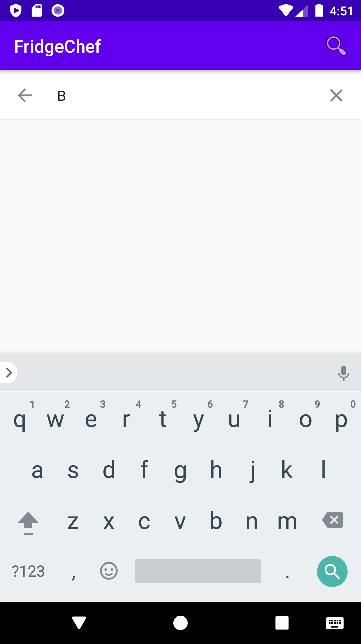

2.

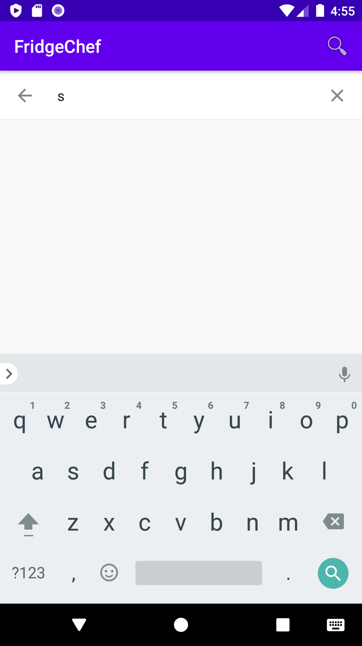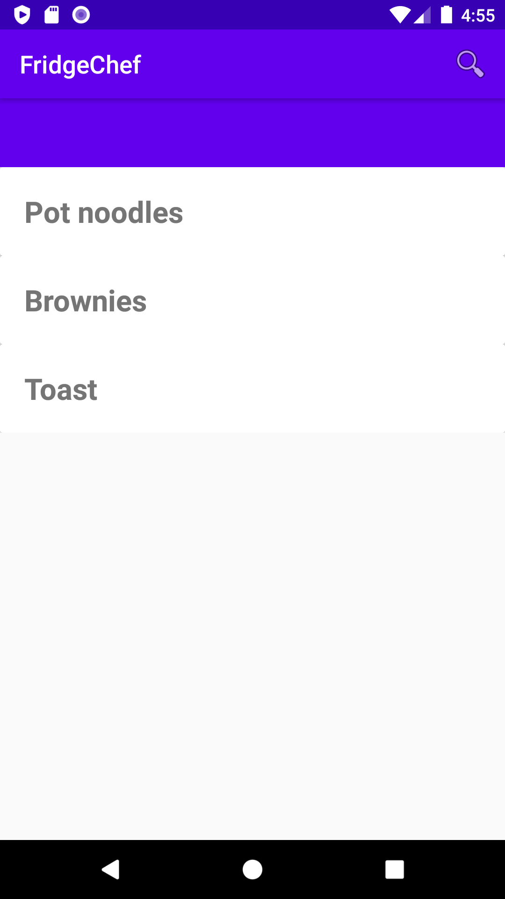

3.

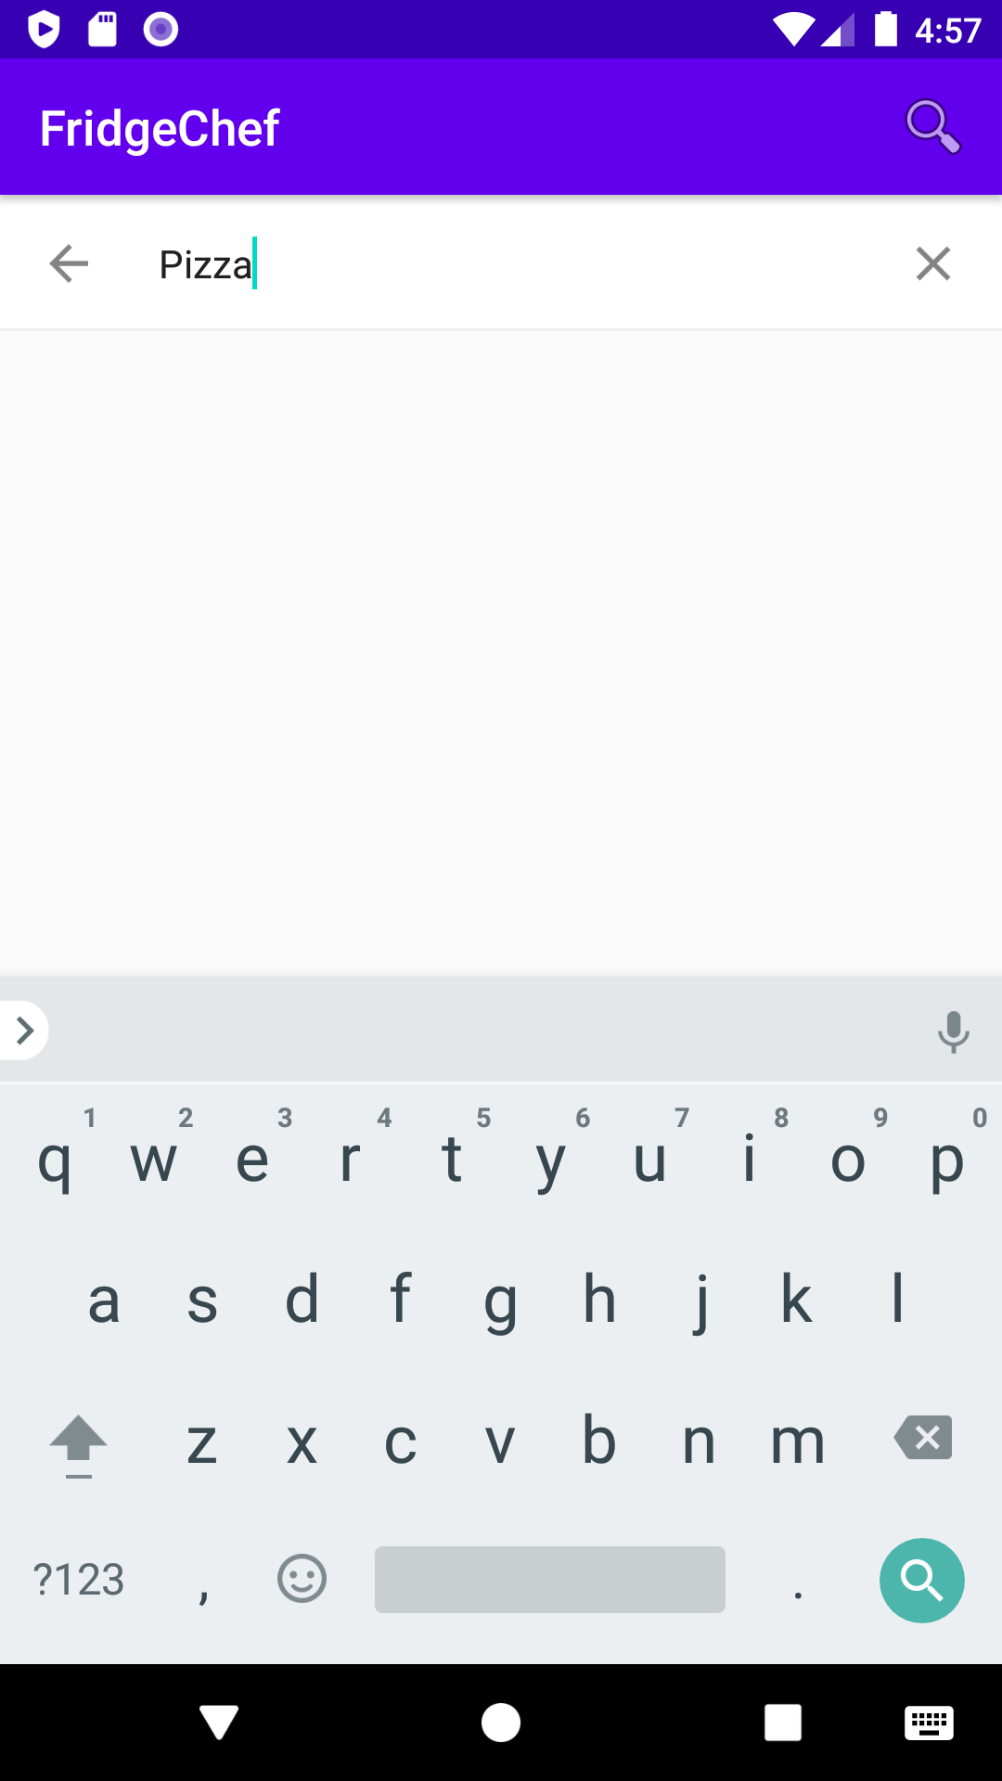

4.

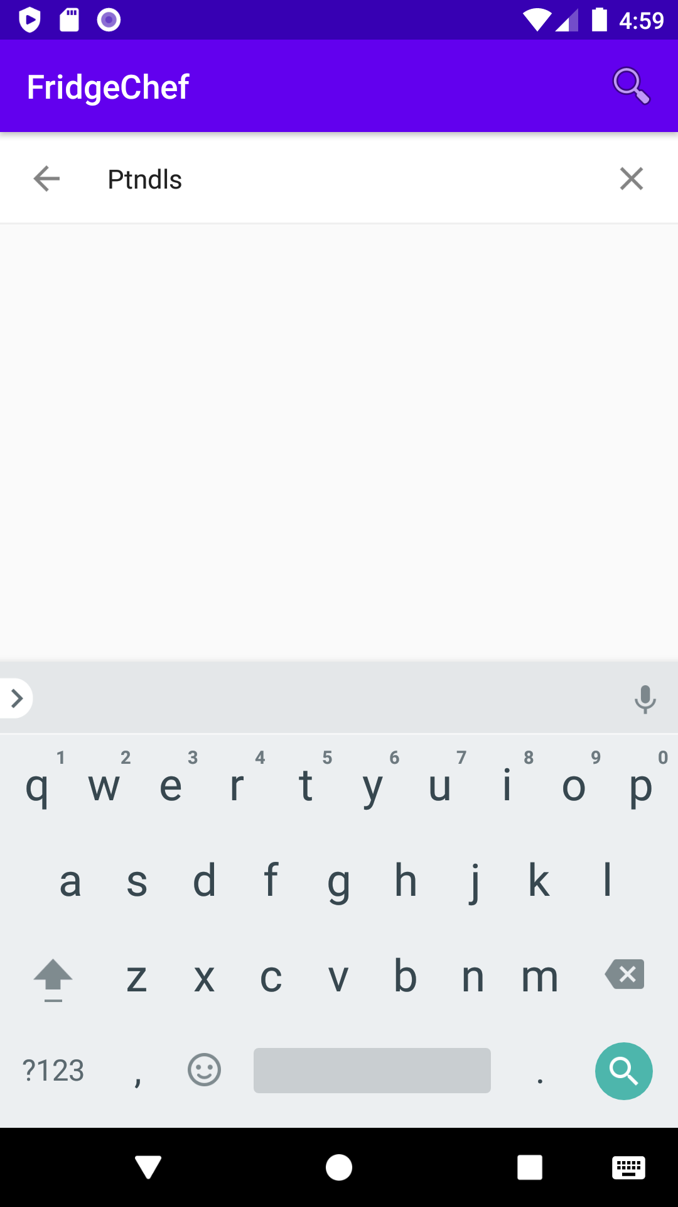

5.

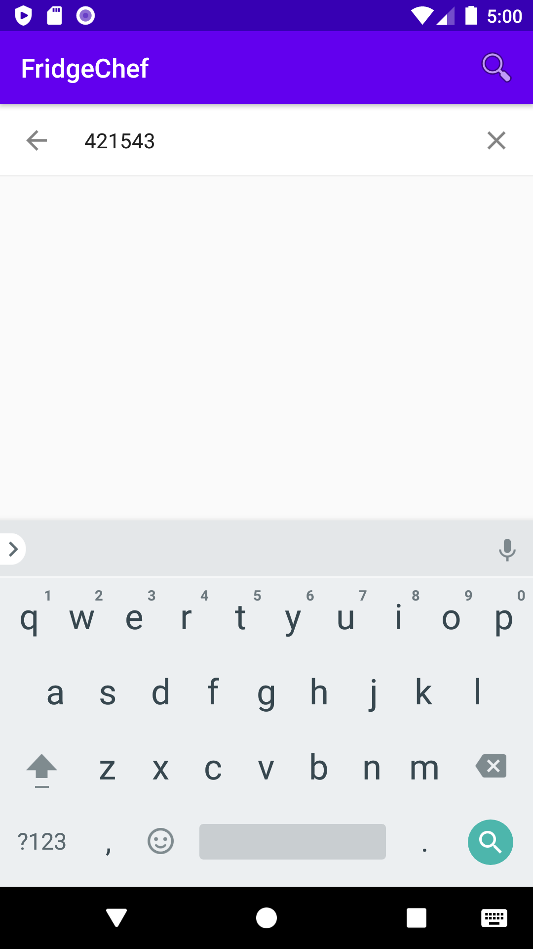

6.

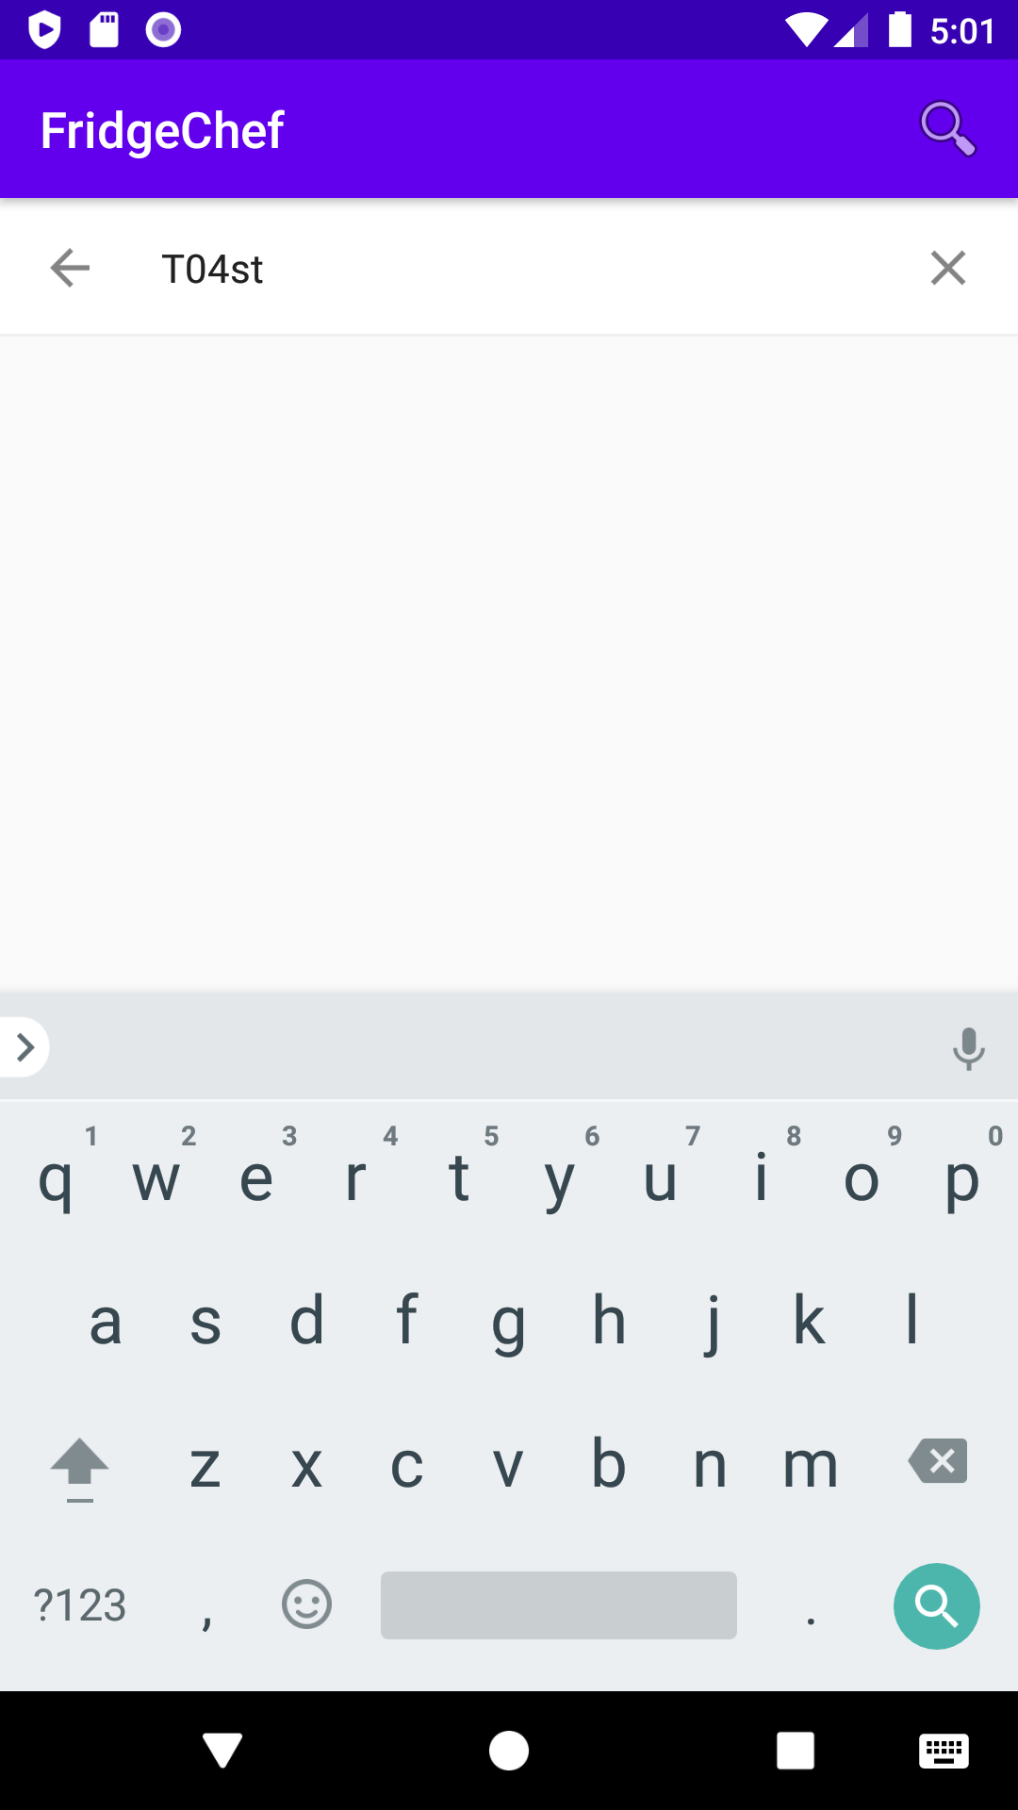

7.

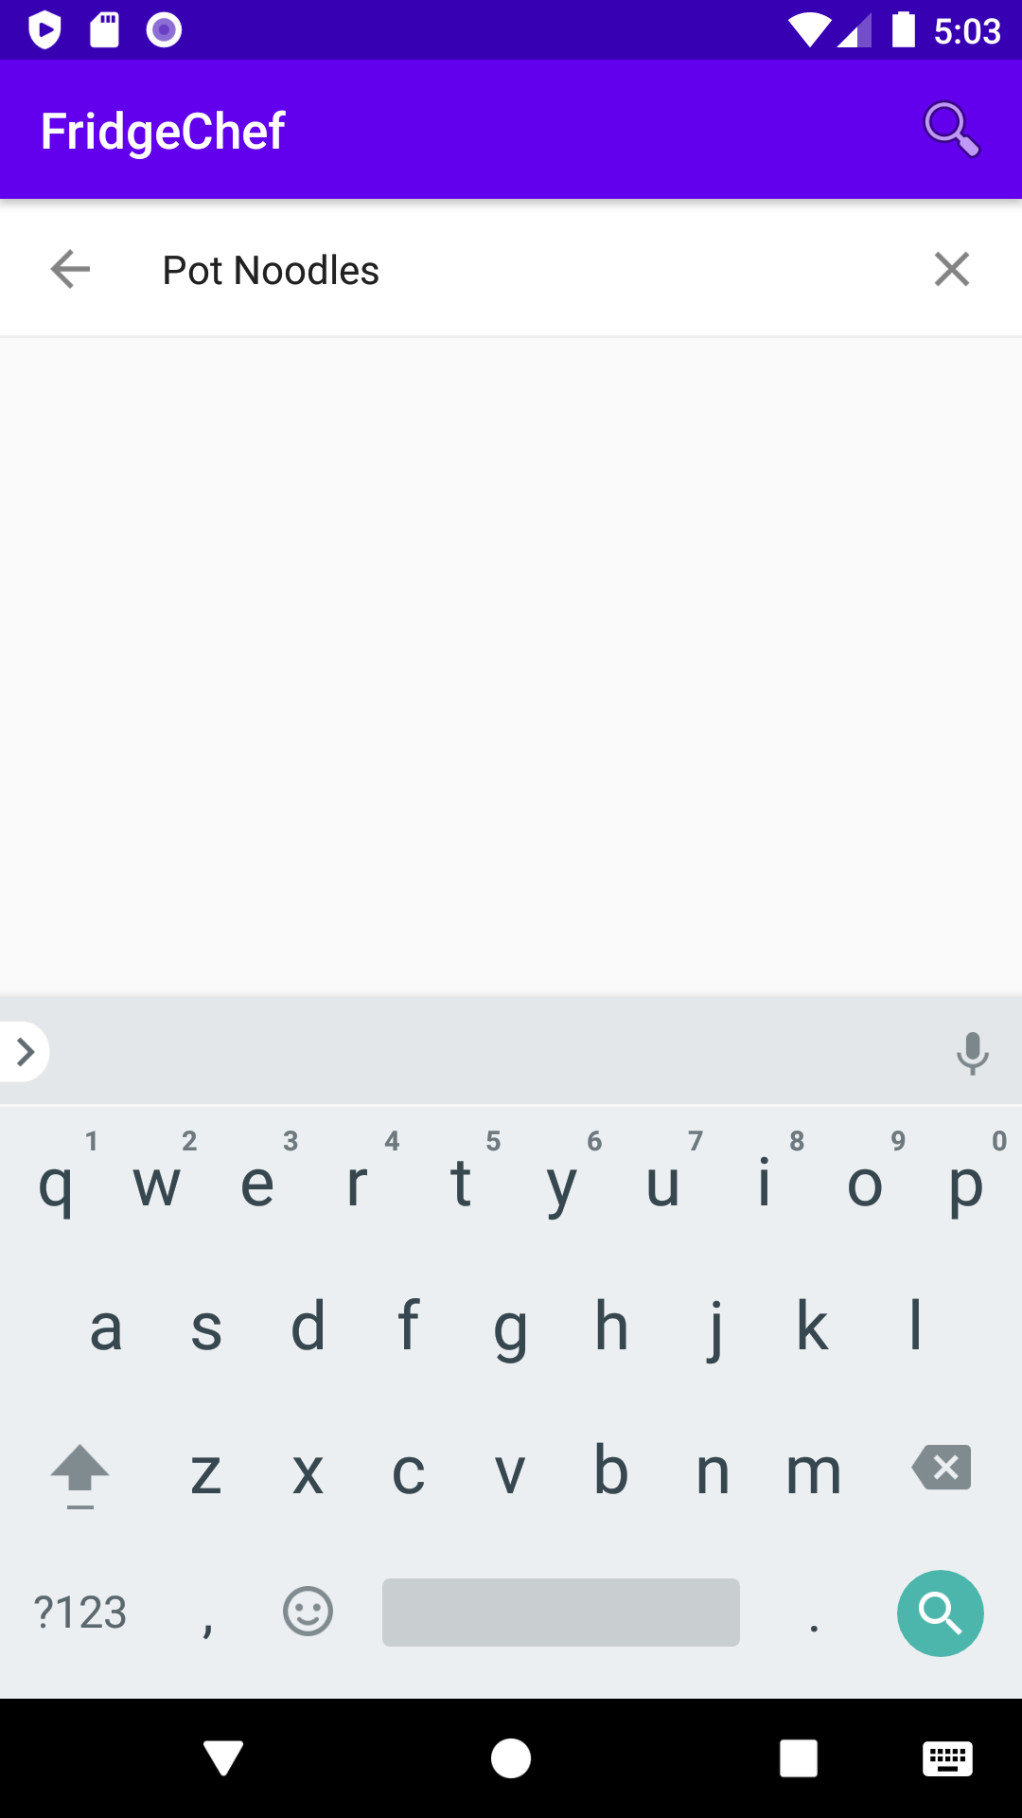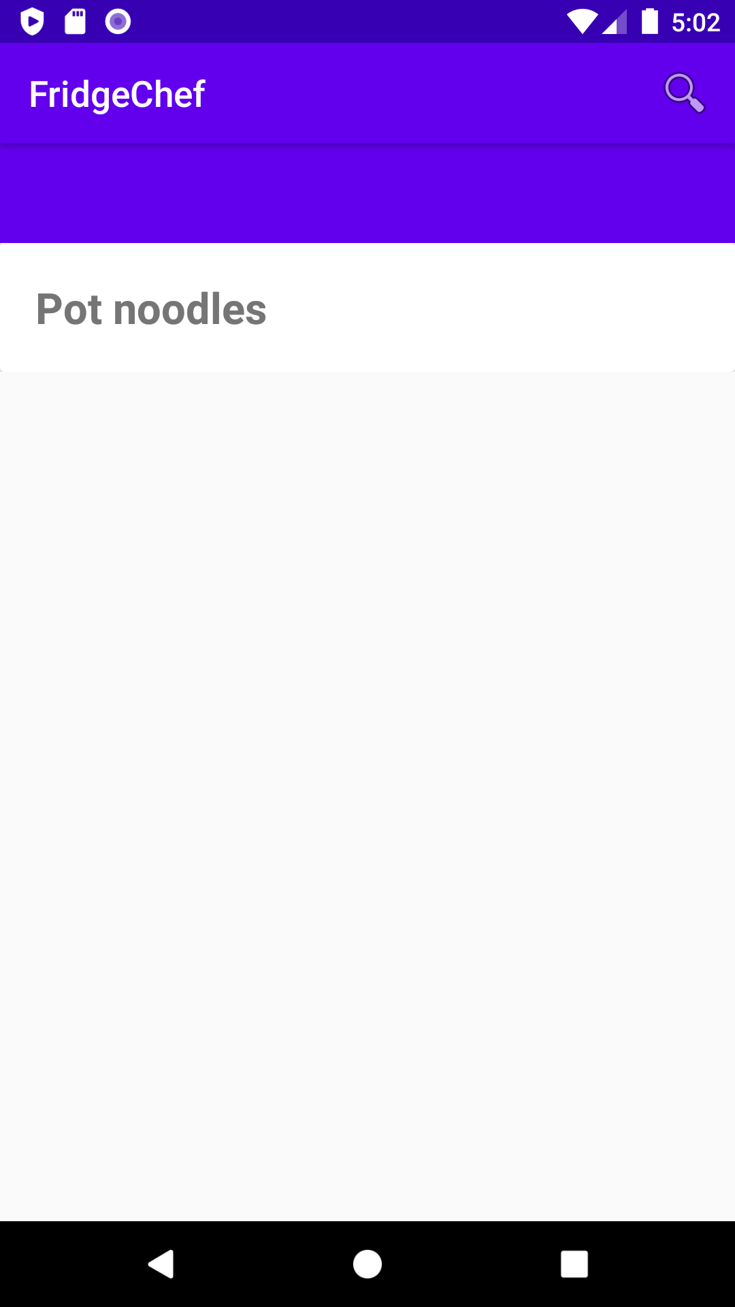

8.

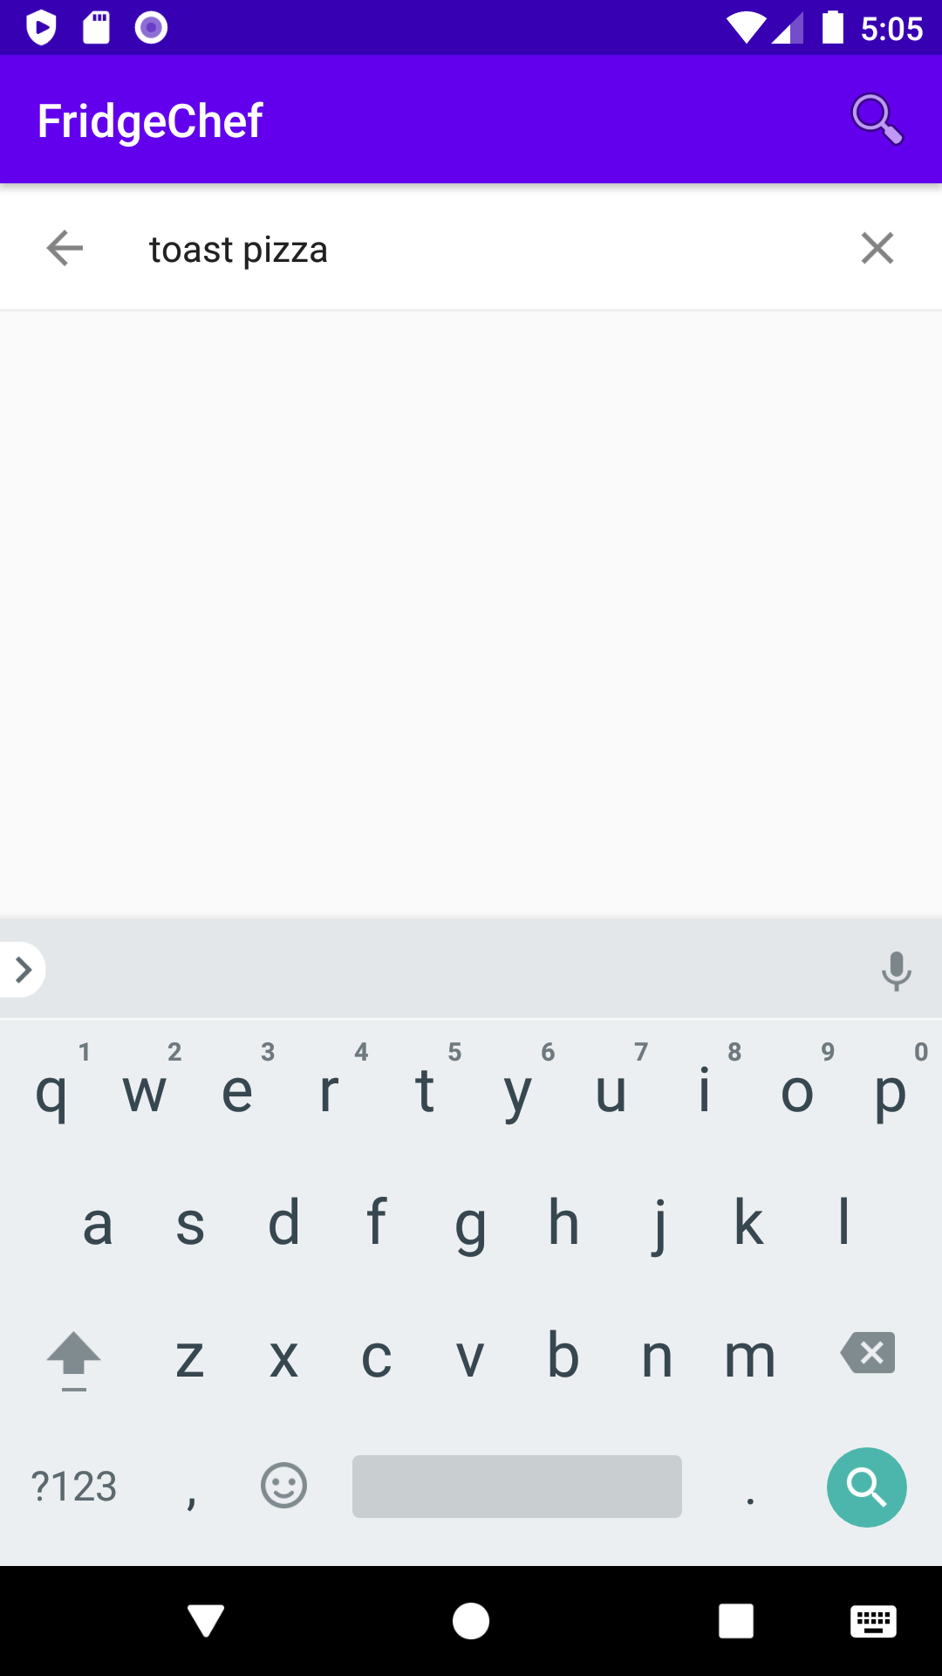

9.

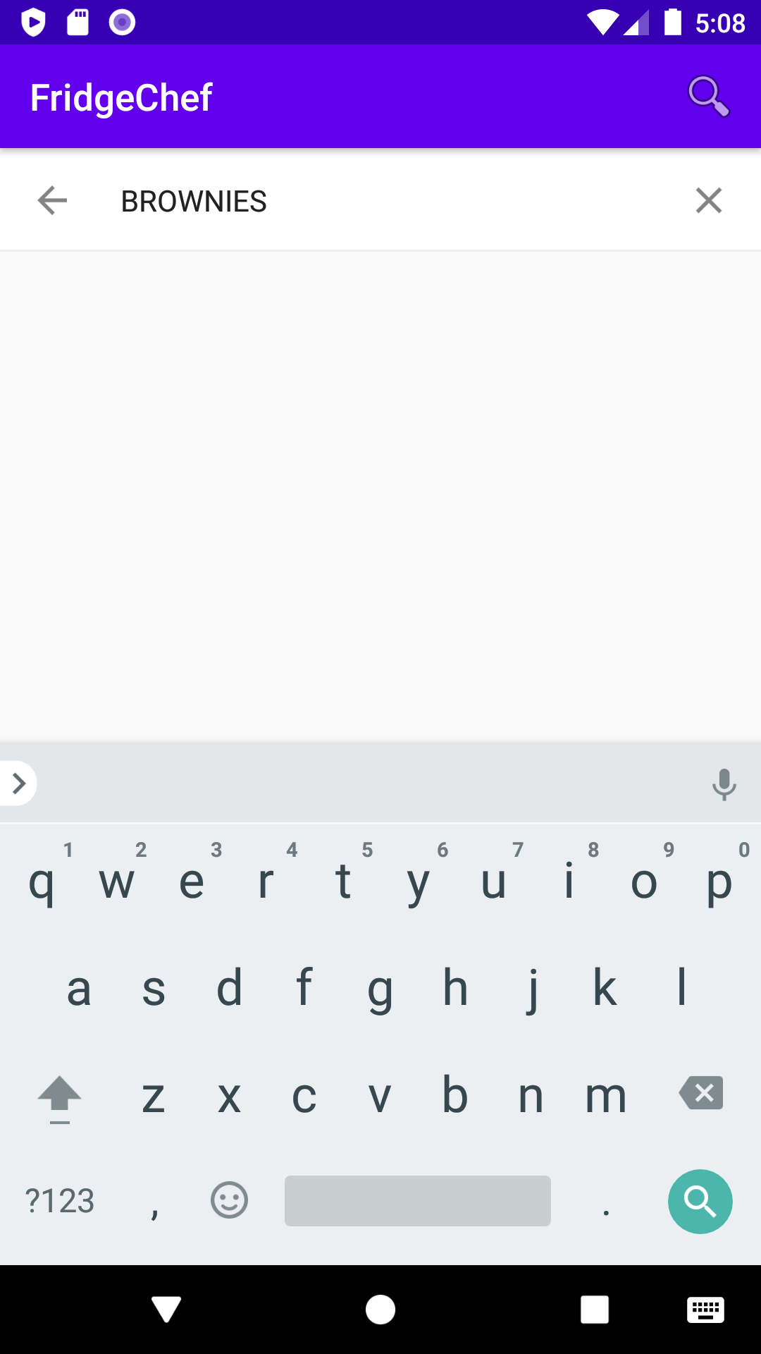

10.

